Design Document

Food Scale Project

Tawsif M, Saqib A.

University of Waterloo

Course Code: ECE 198

# Needs Assessment

## Client and customer definition

University of Waterloo students, like many university students worldwide, face the challenge of the "Freshman 15" problem. As of 2022, the University of Waterloo has approximately 9000 first year students, according to [1], all of which are risk to “Freshman 15” phenomena. This problem refers to the tendency for students, particularly in their first year of college or university, to gain dangerous amounts of weight, affecting short term and long-term health of the individuals as per [2]. This weight gain can be the result of many factors, including, mental health, landscape changes as well as peer pressure.

**Geographic**

University of Waterloo students often reside in the city of Waterloo during their academic years, which can be a significant change from their previous living environments. This shift in location, especially for those who come from different cities or regions, can impact their eating habits due to several landscape and lifestyle changes. Many students transitioning to Waterloo are moving from suburban or rural areas to a more urban environment. In urban settings, access to a wide variety of food options is more convenient. This shift may expose students to new cuisines and dining opportunities, influencing their food choices. Statistics show that individuals who move to areas with high access to fast food restaurants gain on average more weight than users who low move to areas with lower access, according to [3]. Moving into an urban city, such as Waterloo Ontario, allows for more access to more fast food, making this concerning statistic a reality that many students in first year.

**Economic**

Moving to a new location comes with its own costs, especially as a student. With increasing housing costs, as well as undergraduate and graduate tuition, finances play a major factor in a first-year student’s life. Most first-year students are adjusting to newfound financial independence. They often have tight budgets, which can restrict their food choices. Limited funds may lead to prioritizing cheaper, less nutritious options over healthier alternatives. Managing finances can be stressful for first-year students. Financial stress can affect mental health and well-being, which, in turn, may influence eating habits as per [4]. High stress in students is directly linked to higher reward seeking in students, increasing health affecting activities, such as drinking, smoking and overeating according [5]. Stress can lead to emotional eating, poor food choices, or irregular eating patterns as per [6]. In addition, studies show that socioeconomic status is directly linked to weight gain, with students starting a new life with a plethora of new costs, such as tuition and rent, the financial stress that students incur, is something that directly affects their weight.

**Demographic**

University students, particularly first-year students, are often in the age range of late teens to early twenties. This age group is characterized by changing metabolism and dietary preferences. Many students are transitioning from adolescence to adulthood, which can lead to shifts in their eating habits. Teens and young adults are at a stage in life where they are eager to explore new foods and culinary experiences, with friends. The university environment often exposes them to a diverse array of dining options, including restaurants, food trucks, and international cuisine according to [3]. This curiosity can lead to trying different dishes, some of which may be calorically dense, leading to unwanted weight gain, contributing to the weight gain that first years suffer from. Touching on the specific demographic of young students, university is a major shift in a young adult’s time. All the time that an individual once had as a high school student is no longer available, due to newfound responsibilities as well as academic stressors. Students of this age are more likely to sacrifice their mental and physical health, to save some time. This directly impacts their weight, as students are more likely to save a little extra time by grabbing fast food, in turn increasing one’s weight.

## Competitive Landscape

**Health tracking apps:**

Calorie tracking apps such as MyFitnessPal are valuable tools for students to monitor dietary intake and nutritional goals. These apps offer real-time tracking and customization, helping students make informed food choices as per [7]. However, they require a significant time commitment, which can be impractical for busy student schedules, potentially affecting consistency. The rigidity of tracking may lead to an unhealthy obsession with food and body image, impacting mental health and potentially causing restrictive eating habits. It's crucial for students to find a balance between health goals and recognizing the potential drawbacks of time-consuming tracking.

**University Meal Plans:**

The University of Waterloo has appointed dieticians that closely work with the team to provide students with healthy options when choosing what to eat for their meals. Students have opportunities to have various types of meals, even conforming to different dietary restrictions, such as Halal, Vegan, gluten free, etc. according to [8]. Amidst these efforts made by the school, student meal plans allow access for students to have food from all vendors on campus, enabling them to have fast food alternatives such as Pizza Pizza, Subway, Starbucks, etc. These alternatives generally are more popular amongst students, making the efforts of healthy eating through the meal plan less appealing by comparison. Students would much prefer the convenience and familiarity of these fast-food alternatives, which can sometimes overshadow the healthier options provided by the university's dedicated dietitians.

**University Health and Wellness Programs**

At the University of Waterloo, there are campus health and wellbeing programs that educate and encourage students to make healthier choices in their day to day lives. There are charts situated throughout campus that advise students to make these choices, showcasing healthier portion sizes, healthier alternative for the betterment of students as per [9]. However, there are many drawbacks to these systems. Students live busy lives, often rushing to go from one class to another, which often means they are not paying attention to their surroundings. The University of Waterloo’s health and awareness team puts up many posters for their initiative around the campus, near food distribution areas, however many students are unaware of these informative pieces of literature, and often are disregarding them at the time ordering food to save time. Additionally, many of these posters are situated near the food vendors on campus, and campus associated residences, for students with meal plans. Those who are living off campus are not subject to encountering the various posters posted at on campus residences.

## Requirement Specification

**Specification #1**

Weight Measurement Accuracy:

The system's load cell shall accurately and reliably measure the weight of the specified food item with a margin of error not exceeding ±1 gram, as recommended by [10].

**Specification #2**

User Interface and Display using 80x30 mm LCD:

The system shall integrate a 80x30 mm LCD display, as recommended by [11].

**Specification #3**

Dietary goals may include Weight Loss (e.g., 500 calories deficit per day), Weight Maintenance (e.g., equal to BMR), Muscle Gain (e.g., 300-500 calories surplus per day). [12]

**Specification #4**

User Engagement Reminders:

The system shall send regular meal reminders to users every 3 to 4 hours to keep your blood sugar consistent and for your stomach to optimally digest. The importance of regulated mealtimes is emphasised by [13]. A light will blink to serve as the notification.

**Specification #5**

The food scale must be designed to comfortably hold a standard dinner plate with typical dimensions.

The food scale should be able to accommodate plates with an average diameter of 10 inches, as stated in [14]. This ensures that users can place their common dinner plates on the scale without any issues.

# Analysis

## Design

**User Input:**Before our machine can provide its caloric feedback, it necessitates specific user inputs to perform essential calculations. These requisite inputs encompass the following user parameters:

* Gender
* Weight (in kilograms)
* Height (in centimeters)

To ensure a user-friendly and seamlessly integrated experience, our user interface adheres to the meticulous guidelines set forth by the UX Design Institute. This user input stage is facilitated through the utilization of a dedicated button, which is seamlessly integrated with our LCD and functions as a user-friendly counter to streamline the data entry process.

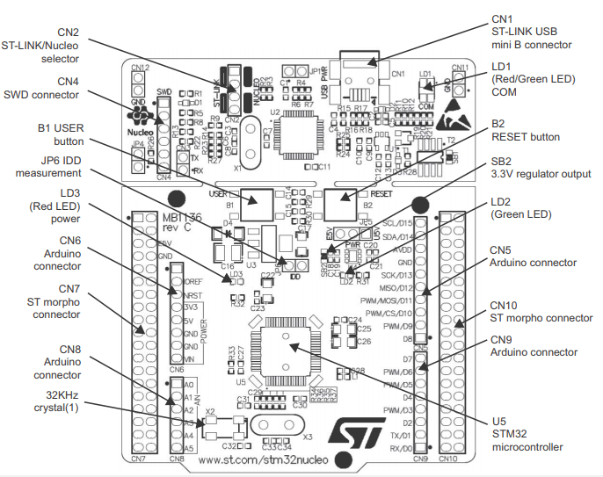

Figure 1: The 'B1 USER Button' within the annotated diagram of our STM board, taken from [15], serves as the control interface for advancing through the counter.

**Programming Logic**

1. BMR Function: Utilizing the user's input data, we will perform calculations to determine the user's Basal Metabolic Rate (BMR). Detailed steps for these calculations are provided later in this document.
2. GetValue Function: To accurately determine the weight of food being measured, we will employ the HX711 module to convert the load cell readings. This process involves interfacing with the HX711 sensor and retrieving the serialized bit values, which are instrumental in translating the physical measurements into meaningful data for our system's calculations.
3. Return Value Function: Upon computing the Basal Metabolic Rate, and with the food measurements obtained from our scale, we will provide the user with a value, either positive or negative. This value serves to guide the user in adjusting their food intake to align with their Basal Metabolic Rate – indicating whether they should consume more or less of the food to maintain a balanced dietary regimen.
4. LED Function: This function is responsible for controlling the LED indicator, offering visual reminders to the user. The calculations for the period of LED blinking, is elucidated further in this document.

**Prototype Design**

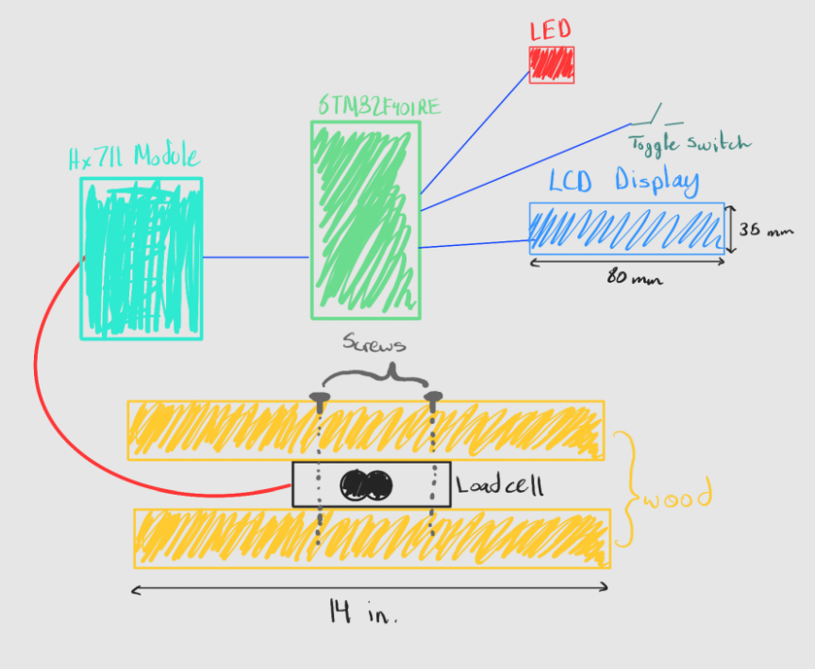

Figure 2: This sketch presents an overview of the essential components integrated into the food scale design.

**Key Features**

The subsequent section delineates the specific characteristics of the antecedent prototype design:

1. Load cell: The load cell serves as a critical physical sensor, primarily responsible for the precise quantification of the weight or force applied to it. Notably, this load cell exhibits a specified maximum capacity, limited to 20 kilograms (kg), delineating the upper threshold of the force it can accurately measure and accommodate. This parameter is paramount for ensuring the proper functioning and safety of the load cell within the designated operational range.
2. Wood and Screws: These elements collectively serve as a foundational platform upon which food items are situated. Given the load cell's inherent limitations in size, it is imperative to consider the combined weight of the wooden platform and securing screws when computing measurements; this weight is customarily deducted during subsequent calculations.

The dimensions of the platform are meticulously designed to align with the specifications of an average dinner plate, measuring precisely 10 inches in diameter according to [16]. To ensure compatibility and provide a margin of adjustment, the platform extends to 14 inches, allowing for an additional 2 inches of space on each side of the dinner plate.

1. HX711 Module: An integral electronic component employed in conjunction with the load cell. Its primary function is to convert the analog signal emanating from the load cell into a digitized format, facilitating subsequent data processing and presentation.
2. LCD Display: This component functions as an interface through which users receive immediate feedback pertaining to their caloric intake, enabling real-time monitoring and visualization.  
     
   The dimensions of the LCD display provide an ample interface for users. Measuring precisely 80 millimeters in width by 35 millimeters in height, this meticulous design choice ensures that users are presented with an appropriately sized display interface.
3. LED: The LED serves as an integral component of our notification system. It is strategically designed to emit intermittent light pulses at predefined intervals, functioning as a visual prompt for the users.
4. Toggle Switch: This is used to switch between user inputs.

## Scientific or Mathematical Principles

**Newton's Law of Motion**

As the load cell used in this project yields readings in Newtons (N), necessitating the application of Newton's fundamental law of motion. Taken from [17], the equation governing an object adhering to this law is expressed as follows: $$F=ma$$ 
Where:

* *F* is the force exerted by the object in Newtons (N)
* *m* is the mass of the object in kilograms (kg)
* *a ­*is the acceleration of the object in meters per second squared (m/s2)

Figure 3: The simplified free body diagram illustrates that the acceleration experienced by an object when placed on our scale corresponds to the gravitational acceleration constant for Earth (g ≈ 9.81 m/s2)

Since our objective is to obtain readings in kilograms (kg), it becomes necessary to isolate the mass of the object, leading to the following equation: $$m=\frac{F}{a}=\frac{F}{g}$$

This principle, while seemingly straightforward, plays an instrumental role in our programming logic. It provides the foundational mathematical framework essential for converting the load cell's readings from Newtons (N) to kilograms (kg).

**Harris-Benedict Principle for BMR Calculation**

The Basal Metabolic Rate (BMR) signifies the quantification of calories expended during the performance of fundamental life-sustaining processes in an individual. In essence, it signifies the caloric expenditure during a day where an individual remains essentially inactive. This crucial metric forms the basis for determining an individual's daily caloric intake requirements. Taken from [18], the calculation is executed as follows:

For men:

$$BMR=66.5+13.75m+5.003h-6.75t$$

For women:

$$BMR=655.1+9.563m+1.850h-4.676t$$

Where:

* *m* is the weight in kg
* *h* is the height in cm
* *t* is the age in years

Upon obtaining the BMR value, designated as 'x', and assuming a measured weight of a meal on the scale, indicated as 'y', the feedback displayed on the LCD is determined through the expression*: $$\frac{x}{3}-y$$

The resultant numerical value signifies the quantity of food to be added (in the case of a negative result) or removed (in the case of a positive result) to align the individual's dietary intake with their BMR-derived caloric requirement. This calculation provides a systematic method to guide individuals in their meal planning based on their unique metabolic needs.

\**x* is divided by 3 as the user should have three meals during the day.

**Center of Mass**

According to [19], the determination of a system's center of mass involves vector addition, wherein each object's weighted position vector, pointing to its individual center of mass, collectively influences the overall position of the system's center of mass. This concept simplifies when analyzed along each axis, as demonstrated below.

$$x_{COM}=\frac{\sum_{i=1}^{N}{m_{i}x_{i}}}{M}$$

$$y_{COM}=\frac{\sum_{i=1}^{N}{m_{i}y_{i}}}{M}$$

In these equations:

* N denotes the number of objects within the system.
* M represents the total mass of the system.
* m is the mass of a specific object.
* x and y denote the respective x or y coordinates of a given object.

This principle of center of mass determination can be effectively applied to ascertain the width of a wooden platform, provided that the length and height have already been established.

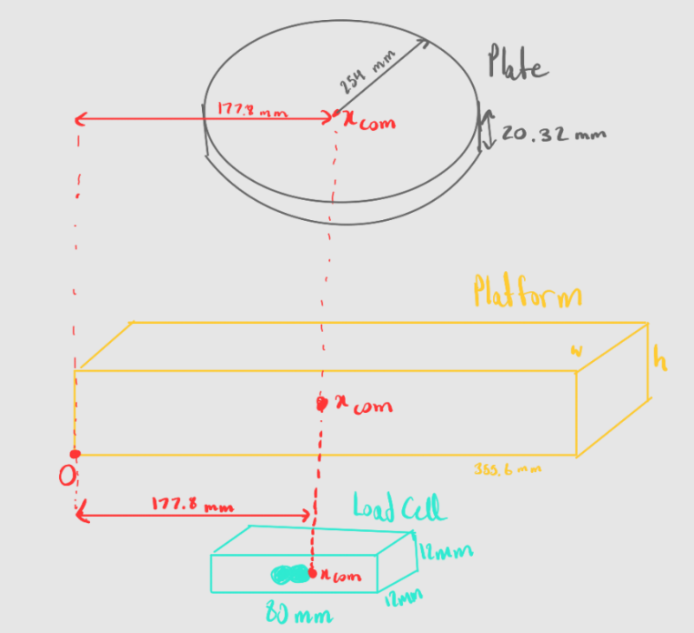

Figure 4. A representation of the dimensions of each object in our system, the x coordinate for the center of mass of each object has already been aligned. For clarity the objects are drawn apart, however they would in reality be in contact.

With reference to the graphical representation of the dimensions of objects within our system, and taking point O(0,0) as the origin, the width (w) of our wooden platform can be determined using the yCOM and zCOM equations. Specifically:

$$y_{COM}=\frac{\sum_{i=1}^{N}{m_{i}y_{i}}}{M}$$

$$y_{COM}=\frac{\left(m_{lc}\right)\left(-6\right)+\left(m_{w}\right)\left(\frac{h}{2}\right)+(m_{p})(h+10.16 )}{M}$$

The density of the wood employed for the platform is 0.01373 kg/in^3, as calculated from given dimensions in [20]. To calculate the mass, this density is multiplied by the volume of the wood. Thus:

$$y_{COM}=\frac{\left(106.06 \right)\left(-6\right)+\left(0.01373*14wh\right)\left(\frac{h}{2}\right)+\left(0.45\right)\left(h+10.16 \right)}{\left(106.06+0.01373*14wh+0.45\right) }$$

$$y_{COM}=\frac{-63178800+9611h^{2}w+45000h}{10651000+19222hw }$$

We are aware that the center of mass coordinates must align with those of the load cell, specifically (177.8, 6). Additionally, it has been established that the height of our wooden platform will measure 26 mm. Hence, it follows that:

$$y_{COM}=\frac{-63178800+9611h^{2}w+45000h}{10651000+19222hw }$$

$$6=\frac{-63178800+9611{\left(26\right)}^{2}w+45000(26)}{10651000+19222(26)w }$$

$$w=200.4 mm$$

Utilizing the equation for center of mass, we successfully ascertained the minimum width of our wooden platform necessary for achieving optimal balance. This design parameter is instrumental in the practical implementation of our system. It is important to note that for precise scientific measurements and analyses, all variables should be meticulously controlled and monitored, and any assumptions or approximations should be clearly stated to ensure the scientific rigor of the experiment.

**Frequency**

The term "frequency" is characterized by the quantity of cycles or repetitions occurring within a given time frame [21]. This definition can be succinctly represented as:

$$f=\frac{1}{T}$$

In this equation, "*T*" signifies the duration required for a single repetition.

To guarantee an effective notification system, our LED needs to attain a specific frequency. We are aiming for 300 Hz, as this will be both noticeable by the human eye and not irritable either. Knowing this we can substitute 300 in for *f* and solve for *T*.

$$T=\frac{1}{f}$$

$$T=\frac{1}{300}$$

$$T=3 ms$$ Using the formula for frequency, we were able to determine a design parameter, the period of each blink for our LED notification system.

# Costs

## Manufacturing Costs

|  |  |  |  |  |  |  |
| --- | --- | --- | --- | --- | --- | --- |
| Quantity | Component | Cost | Manufacturer | Location | Distributor | Location |
| 1 | Load Cell | $13.99 | Geekstory | Seattle, Washington, United States | Amazon | Seattle, Washington, United States |
| 1 | 2-Pack I2C 1602 LCD Display Module | $20.99 | Geeekpi | Cambridge, England, UK | Amazon | Seattle, Washington, United States |
| 1 | 300pcs 3mm, 5mm led Assorted 5 Color LED DIY KIT | $13.99 | Haitronic | Hong Kong | Amazon | Seattle, Washington, United States |
| 1 | Basswood Carving Whittling Blocks | $20.98 | Thiecoc | Northville, Michigan, United States | Amazon | Seattle, Washington, United States |

## Installation Guide

Welcome to the installation and setup guide for our project. We've designed the installation process to be straightforward, but please keep in mind that these guidelines may evolve during the prototype stage.

**1. Power Connection**

Begin by establishing a power connection for the system:

* Connect the STM32 to your computer. This connection will supply the necessary power for the device to function.

**2. Initial Setup (First-Time Use Only)**

On the first use, follow these steps to configure the device:

a. Utilize User Button 1 on the STM32 to input essential information, as directed on the LCD display. This step is crucial for setting up the device properly.

b. Employ the toggle switch to switch between different input options. This is a one-time setup and is required only during the first use of the system.

**3. Food Selection**

To choose the type of food you intend to weigh, follow these steps:

* Utilize the toggle switch and User Button 1 to navigate and select your preferred food item from the available options. This step ensures that the system is calibrated for accurate measurements.

**4. Scale Ready**

Once you've completed the setup and food selection, your scale is primed for use. To begin weighing your food, follow these steps:

* Gently place your plate or container on the scale's surface. The LCD display will promptly provide you with caloric feedback based on the precise measurements.

This installation guide will help you get started with our innovative tech product. Please note that additional features and improvements may be introduced as the product evolves beyond the prototype stage.

## User guide

**Food Scale User Manual**

Welcome to your Food Scale User Manual. This manual provides step-by-step instructions to help you effectively use your innovative food scale. With this device, you can effortlessly manage your daily calorie intake based on your Basal Metabolic Rate (BMR). Achieve accurate calorie tracking and maintain a balanced diet with precise food weighing.

**1. Key Features & Benefits**

* **Accurate Weighing:** Achieve precise portion control with ease.
* **Real-Time Calorie Tracking:** Instantly access calorie information based on your BMR for informed decision-making.
* **Customized Calorie Goals:** Set personal calorie goals in alignment with your Basal Metabolic Rate (BMR).

**2.1 Unpacking and Assembling**

Begin by unpacking the scale components. Assemble the scale and ensure it's placed on a stable, flat surface.

**2.2 Power On**

Connect the STM32 board or your chosen power source and turn on the scale. The LCD screen will illuminate.

**3.1 Setting Up Your BMR**

1. Within the menu, locate the "BMR Setup" option.
2. Use the toggle switch to navigate through the menu options.
3. Press the button to select "BMR Setup."
4. The LCD screen will prompt you to input your personal information, including yourgender, height, and weight.
5. Using the toggle switch and button, toggle through the menu and increment your height and weight and select gender.

**3.2 Weighing Food Based on BMR**

1. Select "Food" from the menu using the toggle switch.
2. Use the button to confirm your selection.
3. Place a plate on the scale.
4. Add your food to the plate, following the instructions displayed on the screen.
5. The scale will calculate the recommended portion size based on your BMR, helping you make informed decisions about your calorie intake.

Figure 5: A flow chart depicting the user input process.

# Risks

## Energy Analysis

**Reference standards:**

$$P=VI$$

**Power Consumption for STM32 Board: $$P=5.0*0.000150*84=0.063W$$**

**Power Consumption for Load Cell:**

$$P=1.6*10^{- 3}*5 =8*10^{-3} W$$**Power Consumption for 2 LCDs**

$$P= 4.5*40*10^{-3}=180*10^{-3} W$$

**Total Power Consumption**

$$P=P1+P2+2P3$$

$P=$ 0.259 W

**Scientific Reasoning and Analysis**

In the energy analysis, it is evident that the food scale exhibits no chemical energy storage, as there is no chemical reactions occurring during the use of our product. Similarly, the absence of mechanical energy storage in the food scale is apparent, as it functions purely as a weight-measuring device and does not incorporate any mechanical energy storage components like springs or flywheels, which would hold types of mechanical such as spring potential energy. Hence chemical and mechanical energy storage will be 0J.

In terms of electrical energy storage, the STM32 Nucleo board does not store any sort of electrical energy, due to the lack of capacitors on the board. Additionally, load cells do not store or accumulate energy in the way that batteries or capacitors do. They do not have the capacity to store or release energy; their sole purpose is to provide a real-time measurement of the force or weight applied to them. The LCD components are passive components in electronic devices, just like load cells. They are designed to display information when powered but do not have the capability to store or accumulate electrical energy. Without the use of capacitors, and only using components that lack the capability of storing energy, the scale stores 0J of electrical energy.

This means that the total energy stored in the system at any given moment is approximately 0 J.

Top of Form

**Project Limits:**

According to the analysis above, the maximum energy consumption of the system at any given point is 0.259 W, and the maximum energy stored at any given point is 0 J, successfully meeting the maximum energy consumption and storage requirements for the project.

## Risk Analysis

1. **Possible negative consequences on safety or the environment from using the design as intended:**
   1. Surface that product is resting on may be subject to physical deformation through extensive use.
   2. Potential electronic waste concerns due to the use of electronic components like STM32 board, LCD screen, HX711 module, and LEDs.
   3. Environmental considerations depending on the materials used for the wood, screws, and wires, such as sustainability and recyclability.
2. **Possible negative consequences on safety or the environment from using the design incorrectly:**
   1. Overloading the food scale could lead to damage, posing safety hazards.
   2. Incorrect placement of food items on the scale may result in spills and safety concerns.
   3. Failure to follow setup or calibration instructions may lead to inaccurate measurements, affecting dietary choices.
3. **Possible negative consequences on safety or the environment from misusing the design or using it in a manner that was not intended:** 
   1. Using the scale for non-food items may result in contamination or damage.
   2. Disassembling or tampering with electronic components without proper knowledge may lead to electrical hazards.
   3. Treating of scale as athletic equipment may result in bodily harm.
4. **Possible ways the design could malfunction:**
   1. Electronic components, like the STM32 board, LCD screen, HX711 module, or LED, may experience malfunctions due to manufacturing defects, wear, or electrical issues.
   2. The load cell may become damaged or lose calibration, impacting measurement accuracy.
   3. Wiring connections might become loose or corroded over time.
5. **Consequences on safety or the environment for each of the failure mechanisms specified:**
   1. Electronic malfunctions could result in inaccurate measurements or pose electrical safety risks.
   2. Load cell damage or calibration issues may lead to inaccurate measurements, impacting dietary choices.
   3. If there are issues with the wiring connections, it may result in a wire being damaged, which may result in excessive heat being put out into the environment.

# Testing Plan

**Specification #1: The system's load cell shall accurately and reliably measure the weight of the specified food item with a margin of error not exceeding ±1 gram.**

1. Test Setup: The test setup involves the finished product, an object of known weight, and a program to convert readings.
2. Environmental Parameters: The dimensions of the computer and project area are specified.
3. Test Inputs: Known weight of the object being measured.
4. Quantifiable Measurement Standard: The input weight is measured in kilograms (kg).
5. Pass Criteria: The program's output must be within ±1 gram of the known weight.

**Specification #2: The system shall integrate an 80x30 mm LCD display.**

1. Test Setup: Utilizing a ruler, pencil, paper, and the LCD display.
2. Environmental Parameters: Ensuring adequate space for all materials.
3. Test Inputs: Measuring the length and width of the LCD display.
4. Quantifiable Measurement Standard: The dimensions of the display should be at least 8 cm by 3 cm, measured accurately.
5. Pass Criteria: The recorded dimensions must be 8 cm by 3 cm.

**Specification #3: Feedback is given to match user’s BMR with no error.**

1. Test Setup: Involves user input, a program to calculate BMR, a program to convert readings, and the finished product.
2. Environmental Parameters: The dimensions of the computer and project area.
3. Test Inputs: Reading from the object on the scale and known caloric values of the food item.
4. Quantifiable Measurement Standard:
   1. BMR should be calculated in caloric units (cal).
   2. Input values should be converted from Newtons (N) to kilograms (kg).
   3. A separate calculation is performed using a database of caloric information.
   4. The return value should be in kilograms.
5. Pass Criteria: The sum of the return values for three meals should equal the user's BMR in calories.

**Specification #4: The system’s notification system should use the max voltage from STM ≈ 5 V.**

1. Test Setup: Utilizing the finished product.
2. Environmental Parameters: Conducted in a room with the lights off.
3. Test Inputs: Measuring the voltage from the STM board.
4. Quantifiable Measurement Standard: The LED should output its highest RGB values, measured in bits. This requires the maximum voltage supply from the STM board, measured in volts (V).
5. Pass Criteria: The voltage reading from the STM board should be approximately 5 V.

**Specification #5: The food scale should be balancing the average plate on top.**

1. Test Setup: Involves the finished product and a plate.
2. Environmental Parameters: The dimensions of the computer and project area.
3. Test Inputs: Placing the plate on the scale.
4. Quantifiable Measurement Standard: Matching the x, y, and z coordinates of the center of mass of the plate with those of the scale, measured in millimeters (mm).
5. Pass Criteria: The plate should balance perfectly on the scale.

# Bibliography

[1] University of Waterloo, “Student Headcounts | Institutional Analysis & Planning,” *Institutional Analysis & Planning*, Mar. 11, 2019. <https://uwaterloo.ca/institutional-analysis-planning/university-data-and-statistics/student-data/student-headcounts>

[2] N. L. Mihalopoulos, P. Auinger, and J. D. Klein, “The Freshman 15: Is it Real?,” *Journal of American College Health*, vol. 56, no. 5, pp. 531–534, Mar. 2008, doi: <https://doi.org/10.3200/jach.56.5.531-534>.

[3] “Can where you move impact future weight gain?,” *www.kpwashingtonresearch.org*. <https://www.kpwashingtonresearch.org/news-and-events/recent-news/news-2022/can-where-you-move-impact-future-weight-gain> (accessed Oct. 20, 2023).

[4] dv276, “Evidence Brief 8: Financial hardships, diet & obesity,” *Communicating Diet and Activity Research*. <https://www.cedar.iph.cam.ac.uk/resources/evidence/eb8-financial-hardships-diet-obesity/#:~:text=Whilst%20those%20with%20greater%20hardships>

[5] C. Lemon and A. Del Arco, “Intermittent social stress produces different short- and long-term effects on effort-based reward-seeking behavior,” *Behavioural Brain Research*, vol. 417, p. 113613, Jan. 2022, doi: <https://doi.org/10.1016/j.bbr.2021.113613>.

[6] “Stress and Health,” *The Nutrition Source*, Oct. 05, 2020. <https://www.hsph.harvard.edu/nutritionsource/stress-and-health/#:~:text=%5B2%5D%20Stress%20also%20creates%20a>

[7] MyFitnessPal, “MyFitnessPal | MyFitnessPal.com,” *Myfitnesspal.com*, 2022. <https://www.myfitnesspal.com/>

[8] “Nutrition,” *UW Food Services*, Apr. 05, 2019. <https://uwaterloo.ca/food-services/nutrition-0>

[9] “Guide to healthy eating,” *Campus Wellness*, Aug. 14, 2012. <https://uwaterloo.ca/campus-wellness/nutrition-articles/guide-healthy-eating>

[10] “How Accurate Should My Scale Be?,” *Truweigh*. <https://www.truweigh.com/blogs/news/how-accurate-should-my-scale-be>

[11] L. Bruton, “User interface guidelines: 10 essential rules to follow - UX Design Institute,” *www.uxdesigninstitute.com*, Jul. 27, 2022. <https://www.uxdesigninstitute.com/blog/10-user-interface-guidelines/>

[12] D. Barbagallo, “How To Make A Health & Fitness App More Engaging - Dominique Barbagallo - Medium,” *Medium*, Jan. 12, 2021. <https://cardian.medium.com/how-to-make-a-health-fitness-app-more-engaging-28d47c375c23>

[13] “Scheduled Eating- Why It’s Beneficial and How to Start – Center for Healthy Eating and Activity Research,” *Chear*, Mar. 27, 2020. <https://chear.ucsd.edu/blog/scheduled-eating-why-its-beneficial-and-how-to-start>

[14] “What Size is a Dinner Plate?,” *Made In Cookware*. <https://madeincookware.com/blogs/dinner-plate-size>

[15] “STM32 Nucleo F401RE Development Board,” *Components101*. <https://components101.com/microcontrollers/stm32-nucleo-f401re-pinout-datasheet> (accessed Oct. 25, 2023).

[16] “Choosing The Right Size Of Plates - Everything you need to know about plates,” *AGC Catering Equipment*. <https://www.agcequipment.com.au/blog/choosing-the-right-size-of-plates-everything-you-n/>

[17] khan academy, “Newton’s second law of motion (video),” *Khan Academy*, 2011. <https://www.khanacademy.org/science/hs-physics/x215e29cb31244fa1:forces-and-motion/x215e29cb31244fa1:force-mass-and-acceleration/v/newton-s-second-law-of-motion#:~:text=Newton>

[18] “BMR Calculator - Basal Metabolic Rate Calculator - Omni,” *Omnicalculator.com*, 2019. <https://www.omnicalculator.com/health/bmr>

[19] R. Nave, “Center of Mass,” *Gsu.edu*, 2019. <http://hyperphysics.phy-astr.gsu.edu/hbase/cm.html>

[20] “BeaverCraft BW10 Basswood Carving Blocks Set Bass Wood for Wood Carving Unfinished Wood Blocks - Whittling Wood Soft Carving Wood Blocks for Carving Wooden Block Set Block of Wood for Crafts : Amazon.ca: Home,” *www.amazon.ca*. <https://www.amazon.ca/BeaverCraft-BW10-Basswood-Carving-Blocks/dp/B08D9ST5PF> (accessed Oct. 31, 2023).

[21] Wikipedia Contributors, “Frequency,” Wikipedia, Sep. 01, 2019. <https://en.wikipedia.org/wiki/Frequency>